From: i am that i am; i am who i am;
cell: 0612708467
email: jesseperezcasanova@outlook.com

This email communication; document; trespass letter; record of wrong doing and notice liability is given to all [wo]man ACTING as outlined points of contact below who falsely [fraudulently] ACT as workers who work for service corporation known as THE REPUBLIC OF SOUTH AFRICA; said document will be referred to as said declaration in this document as well as all other documents in reference to this one; said declaration is also given to all [wo]man falsely [fraudulently] ACTING as workers [employees] for corporations recorded [registered] within said service corporations control [jurisdiction]; all [wo]man outlined in contact section below are required to deliver said declaration to those responsible for making sure this is given to ACTING president of The Republic of South Africa immediately; all said [wo]man are also required to give this said declaration to any other [wo]man who falsely [fraudulently] ACT as workers [employees] who work for any corporation recorded [registered] within said service corporation’s [THE REPUBLIC OF SOUTH AFRICA] legal jurisdiction; as well as making sure that it is know that this declaration is to be given to every corporation recorded within said service corporations control [jurisdiction]; this is also being given to all [wo]man outlined in contact information section below;

date: 31ST March 2022

This trespass letter; record of wrong doing and notice liability is given to every [wo]man outlined in the provided contact information section below;

this record of wrong doing will be edited and updated as time progresses;

START OF CONTACT INFORMATION SECTION

Presidency [ The Department in ]
Website: https://www.thepresidency.gov.za/
Email: president@presidency.gov.za
Postal Address: Private Bag X1000, PRETORIA, 0001
Street Address: The Presidency, Union Buildings, Government Avenue, PRETORIA
phone: 012 300 5200

[wo]man ACTING as Director-General PHINDILE BALENI, Ms
Email: informationofficer@presidency.gov.za
Postal Address: Private Bag X1000, PRETORIA, 0001
Street Address: The Presidency, Union Buildings, Government Avenue, PRETORIA
Phone: 012 300 5354

[wo]man ACTING as Media Liaison Officer BONGANI MAJOLA, Mr
Postal Address: Private Bag X1000, PRETORIA, 0001
Street Address: The Presidency, Union Buildings, Government Avenue, PRETORIA
Phone: 012 300 5242

Cell: 082 339 1993

E-mail: BonganiM@presidency.gov.za

[wo]man ACTING as Personal Assistant: NOKUKHANYA CELE, Ms
Postal Address: Private Bag X1000, PRETORIA, 0001
Street Address: The Presidency, Union Buildings, Government Avenue, PRETORIA
Phone: 012 300 5354 / 021 464 2210

E-mail: nokukhanya@presidency.gov.za

[wo]man ACTING as Information Officer (PAIA) PHINDILE BALENI, Ms
Postal Address: Private Bag X1000, PRETORIA, 0001
Street Address: The Presidency, Union Buildings, Government Avenue, PRETORIA
Phone: 012 300 5200
E-mail: informationofficer@presidency.gov.za

Office of Chief Justice

Website: https://www.judiciary.org.za/
Email: enquiries@judiciary.org.za
Postal Address: Private Bag X1, Constitution Hill, Braamfontein, 2017
Private Bag X10, Marshalltown, 2107
Street Address: Constitutional Court of South Africa, Constitution Hill, 1 Hospital Street, Braamfontein, 2017 188 14th Road, Noordwyk, Midrand, 1685
phone: 011 359 7400 / 010 493 2500

[wo]man ACTING as Chief Justice MOGOGENG MOGOGENG
Postal Address: Private Bag X1, Constitution Hill, Braamfontein, 2017
Street Address: Constitutional Court of South Africa, Constitution Hill, 1 Hospital Street, Braamfontein, 2017
Phone: 011 359 7400
E-mail: info@concourt.org.za

[wo]man ACTING as Chief Executive Officer GOMOLEMO MOSHOEU, Dr
Postal Address: Private Bag X10, Marshalltown, 2107
Street Address: 188 14th Road, Noordwyk, Midrand, 1685
Phone: 010 493 2618
E-mail: gmoshoeu@judiciary.org.za

[wo]man ACTING as Secretary-General MEMME SEJOSENGWE, Ms

Postal Address: Private Bag X10, Marshalltown, 2107
Street Address: 188 14th Road, Noordwyk, Midrand, 1685
Phone: 010 493 2500
E-mail: dmoekoa@judiciary.org.za

[wo]man ACTING as Information Officer (PAIA) MEMME SEJOSENGWE, Ms

Postal Address: Private Bag X10, Marshalltown, 2107
Street Address: 188 14th Road, Noordwyk, Midrand, 1685
Phone: 010 493 2500
E-mail: dmoekoa@judiciary.org.za

[wo]man ACTING as Deputy Information Officer (PAIA) JAKES JACOBS, Mr

Postal Address: Private Bag X10, Marshalltown, 2107
Street Address: 188 14th Road, Noordwyk, Midrand, 1685
Phone: 010 493 2575
E-mail: nphakola@judiciary.org.za

[wo]man ACTING as Media Liaison Officer; NATHI MNCUBE, MR
Postal Address: Private Bag X10, Marshalltown, 2107
Street Address: 188 14th Road, Noordwyk, Midrand, 1685
Phone: 010 493 2500
E-mail: mediaenquiries@judiciary.org.za

Office of CONSTITUTIONAL COURT contact information section

It is the requirement [obligation] of all above and below said [wo]man who work in Office of CONSTITUTIONAL COURT or any of the outlined below DIVISIONS of corporation known as CONSTITUTIONAL COURT OF SOUTH AFRICA or for CONSTITUTIONAL COURT OF SOUTH AFRICA itself to make sure that this is given to all [wo]man who ACT as workers [employees] of any of the above and below mentioned corporations as well as the [wo]man ACTING as JUSTICES found below;

[wo]man ACTING as JUSTICE MYBUYISELI MADLANGA; MYBUYISEL RUSSEL MADLANGA

[wo]man ACTING as JUSTICE STEVEN ARNOLD MAJIEDT; STEVEN ARNOLD MAJIEDT

[wo]man ACTING as JUSTICE MHLANTLA NONKOSI ZOLISWA; MHLANTLA NONKOSI ZOLISWA

[wo]man ACTING as JUSTICE THERON, LEONA VALERIE; THERON, LEONA VALERI

[wo]man ACTING as JUSTICE ZUKISA LAURAH LUMKA TSHIQI; ZUKISA LAURAH LUMKA TSHIQ

I[wo]man ACTING as JUSTICE NARANDRA JODY KOLLAPEN; NARANDRA JODY KOLLAPEN

[wo]man ACTING as JUSTICE JUSTICE RAMMAKA STEVEN MATHOPO; RAMMAKA STEVEN MATHOPO

below is the contact information of [wo]man required give this document to all [wo]man ACTING as JUDGES as outlined above; the information of all ACTING [wo]man mentioned below in Office of CONSTITUTIONAL COURT contact information section outlined above was provided by CONSTITUTIONAL COURT OF SOUTH AFRICA official website with the following website URL - https://www.concourt.org.za/index.php/contact-us/superior-courts-contacts
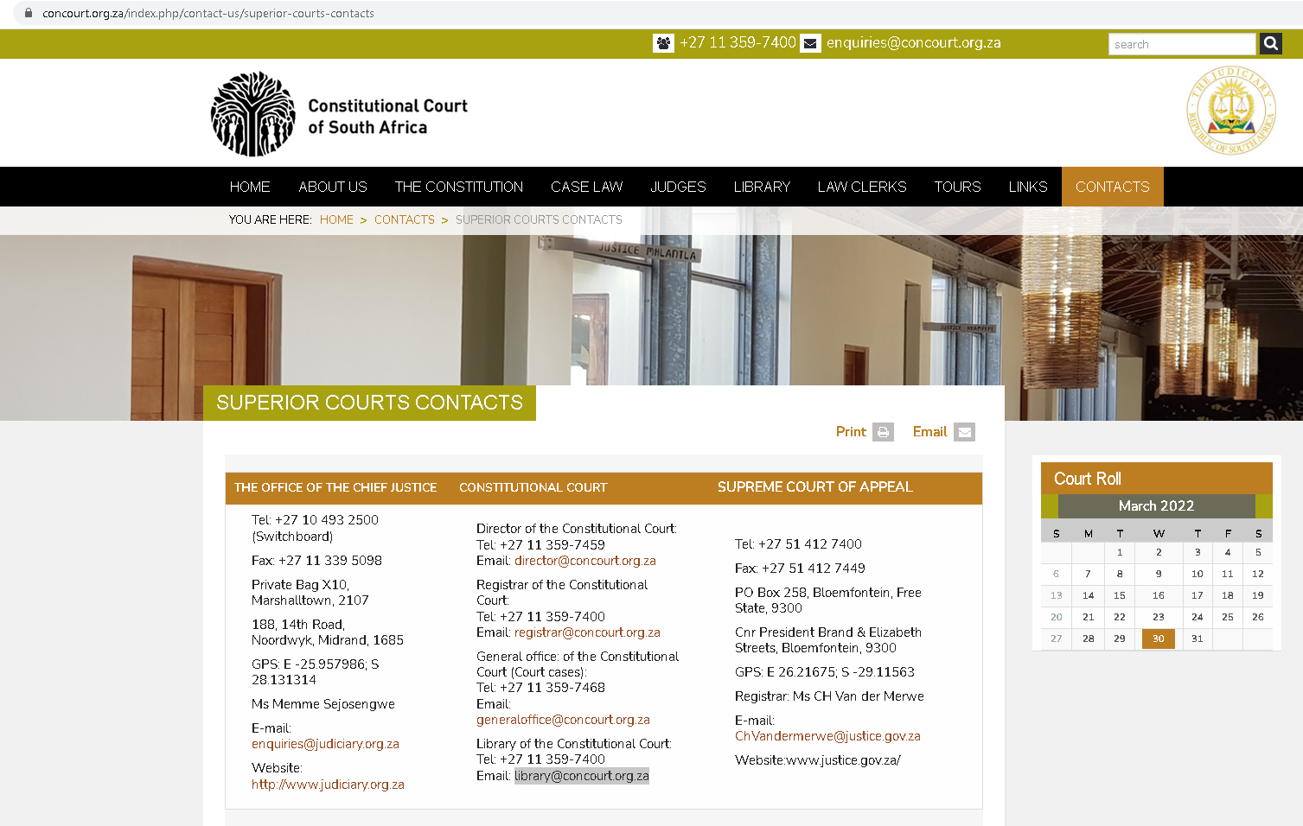
This was provided on to 30th March 2022 and here is a screen shot below;

[wo]man ACTING as Director of the Constitutional Court; LEGAL NAME NOT AVAILABLE ON OFFICIAL WEBSITE
Postal Address: Private Bag X10, Marshalltown, 2107
Street Address: 188 14th Road, Noordwyk, Midrand, 1685
Phone: +27 11 359-7459
E-mail: director@concourt..org.za

[wo]man ACTING as Registrar of the Constitutional Court; LEGAL NAME NOT AVAILABLE ON OFFICIAL WEBSITE
Postal Address: NOT AVAILABLE
Street Address: NOT AVAILABLE
Phone: +27 11 359-7400
E-mail: registrar@concourt.org.za

[wo]man ACTING as workers [employees] of the General office of the Constitutional court; LEGAL NAMES NOT AVAILABLE ON OFFICIAL WEBSITE
Postal Address: NOT AVAILABLE
Street Address: NOT AVAILABLE
Phone: +27 11 359-7468
E-mail: generaloffice@concourt.org.za

[wo]man ACTING as workers [employees] of the General office of Library of the Constitutional Court; LEGAL NAMES NOT AVAILABLE ON OFFICIAL WEBSITE
Postal Address: NOT AVAILABLE
Street Address: NOT AVAILABLE
Phone: +27 11 359-7468
E-mail: library@concourt.org.za

EASTERN CAPE LOCAL DIVISION, BISHO

[wo]man ACTING as Registrar of EASTERN CAPE LOCAL DIVISION; MS T MAFALALA
Postal Address: Private Bag X 0003, Bisho, 5605
Physical Address: 10, Independence Avenue, Bisho, 5600
Phone: 040 608 7700
E-mail: tmafalala@judiciary.org.za

GAUTENG DIVISION, PRETORIA

[wo]man ACTING as Acting Chief Registrar for GAUTENG DIVISION, PRETORIA MS ROANNE BRAMDAW
Postal Address: Private Bag X7 Johannesburg, 2000
Physical Address: Cnr Kruis & Pritchard Streets, Johannesburg, 2001
Phone: 011 335 0000
E-mail: RBramdaw@justice.gov.za

FREE STATE DIVISION, BLOEMFONTEIN

[wo]man ACTING as Acting Chief Registrar for GAUTENG DIVISION, PRETORIA MR S MAPOSSA
Postal Address: Private Bag x 20612, Bloemfontein, 9300
Physical Address: cnr Fountain & Pres Brand Street, Bloemfontein, 9300
Phone: 051 406 8100
E-mail: SMapossa@justice.gov.za

NORTH WEST DIVISION, MAHIKENG (MMABATHO)

[wo]man ACTING as Registrar for NORTH WEST DIVISION, MAHIKENG (MMABATHO) MR LM MOKETE
Postal Address: Private Bag X2010 Mmabatho 2735
Physical Address: C/O Hector Peterson & University Drive Mmabatho
Phone: 018 392 8200
E-mail: LMokete@judiciary.org.za

WESTERN CAPE DIVISION, CAPE TOWN
[wo]man ACTING as Chief Registrar for WESTERN CAPE DIVISION,

CAPE TOWN MS ROANNE DAVID
Postal Address: Private Bag x 9020, Cape Town, 8000
Physical Address: 35 Keerom Street, Cape Town, 8001
Phone: 021 480 2411/2636
E-mail: RDavid@judiciary.org.za

NORTHERN CAPE DIVISION, KIMBERLY

[wo]man ACTING as Registrar for NORTHERN CAPE DIVISION, KIMBERLY MR C CONRADIE
Postal Address: Private Bag x 5043, Kimberley, 8300
Physical Address: Sol Plaatje Drive, Kimberley, 8301
Phone: 053 833 1441
E-mail: CConradie@justice.gov.za

LIMPOPO LOCAL DIVISION, THOHOYANDOU

[wo]man ACTING as Registrar for LIMPOPO LOCAL DIVISION, THOHOYANDOU MS J GWANGWA
Postal Address: Private Bag X5015,Thohoyandou, 0950
Physical Address: Government Buildings Complex, next to Khoroni Hotel, (c/o Mphephu and Parliament), Thohoyandou, 0950
Phone: 015 960 9550
E-mail: JGwangwa@justice.gov.za

LIMPOPO DIVISION, POLOKWANE

[wo]man ACTING as Chief Registrar for LIMPOPO DIVISION, POLOKWANE MS M PHASWANE
Postal Address: Private Bag x9696, Polokwane, 0700
Physical Address: 36 Biccard and Bodenstein Street, Polokwane, 0700
Phone: 015 230 4000
E-mail: MPhaswane@justice.gov.za

KWAZULU-NATAL DIVISION, PIETERMARTIZBURG

[wo]man ACTING as Registrar for KWAZULU-NATAL DIVISION, PIETERMARTIZBURG MS N P FENTE
Postal Address: Private Bag x 9014, Pietermartizburg, 3200
Physical Address: 301 Church Street, Pietermarizburg, 3200
Phone: 033 345 8211
E-mail: PFente@judiciary.org.za

[Director of Corporation known as SABC TV LICENCES]

[wo]man ACTING as Director of SABC TV LICENCES SILVIA TLADI
Postal Address: NOT AVAILABLE
Phone: was not given when requested
E-mail: : [email of legal department that works under Silvia Tladi] tvlic.info@sabc.co.za
[Director of Corporation known as REVCO or REVENUE CONSULTING]

[wo]man ACTING as Director of Revenue Consulting VUSI JENNINGS
Postal Address: 11 Lakeview Crescent, Benoni, Gauteng, 1500, South Africa.
Phone: was not given when requested
E-mail: vusij@revenueconsulting.co.za

END OF CONTACT INFORMATION SECTION

Trespass by; [wo]man ACTING as President [CYRILL RAMAPHOSA] of service corporation known as THE REPUBLIC OF SOUTH AFRICA;

[wo]man ACTING as Director of SABC TV LICENCES SILVIA TLADI;

[wo]man ACTING as Director of Revenue Consulting VUSI JENNINGS;

[wo]man ACTING as Registrar for KWAZULU-NATAL DIVISION, PIETERMARTIZBURG MS N P FENTE;

[wo]man ACTING as Chief Registrar for LIMPOPO DIVISION, POLOKWANE MS M PHASWANE;

[wo]man ACTING as Registrar for LIMPOPO LOCAL DIVISION, THOHOYANDOU MS J GWANGWA;

[wo]man ACTING as Registrar for NORTHERN CAPE DIVISION, KIMBERLY MR C CONRADIE;

[wo]man ACTING as Chief Registrar for WESTERN CAPE DIVISION,
CAPE TOWN MS ROANNE DAVID;

[wo]man ACTING as Registrar for NORTH WEST DIVISION, MAHIKENG (MMABATHO) MR LM MOKETE
[wo]man ACTING as Acting Chief Registrar for GAUTENG DIVISION, PRETORIA MR S MAPOSSA

[wo]man ACTING as Acting Chief Registrar for GAUTENG DIVISION, PRETORIA MS ROANNE BRAMDAW;
[wo]man ACTING as Registrar of EASTERN CAPE LOCAL DIVISION; MS T MAFALALA

[wo]man ACTING as workers [employees] of the General office of Library of the Constitutional Court; LEGAL NAMES NOT AVAILABLE ON OFFICIAL WEBSITE;
[wo]man ACTING as workers [employees] of the General office of the Constitutional court; LEGAL NAMES NOT AVAILABLE ON OFFICIAL WEBSITE;

[wo]man ACTING as Registrar of the Constitutional Court; LEGAL NAME NOT AVAILABLE ON OFFICIAL WEBSITE;
[wo]man ACTING as JUSTICE JUSTICE RAMMAKA STEVEN MATHOPO; RAMMAKA STEVEN MATHOPO;

[wo]man ACTING as JUSTICE MYBUYISELI MADLANGA; MYBUYISEL RUSSEL MADLANGA;

[wo]man ACTING as JUSTICE STEVEN ARNOLD MAJIEDT; STEVEN ARNOLD MAJIEDT;

[wo]man ACTING as JUSTICE MHLANTLA NONKOSI ZOLISWA; MHLANTLA NONKOSI ZOLISWA;

[wo]man ACTING as JUSTICE THERON, LEONA VALERIE; THERON, LEONA VALERI

[wo]man ACTING as JUSTICE ZUKISA LAURAH LUMKA TSHIQI; ZUKISA LAURAH LUMKA TSHIQI;

[wo]man ACTING as JUSTICE NARANDRA JODY KOLLAPEN; NARANDRA JODY KOLLAPEN;

[wo]man ACTING as Chief Justice RAYMOND ZONDO;
[wo]man who ACTED as Chief Justice MOGOGENG MOGOGENG;

[wo]man ACTING as Director-General PHINDILE BALENI, MS;

This trespass letter; record of wrong doing and notice liability is given

read declaration of i; notice liability; record of wrong doing and trespass letters referred to below; this trespass letter; record of wrong doing and notice liability is an extension of declaration of i; notice liability; record of wrong doing and trespass letters referred to below updated; edited and given again on 31st March 2022;

all said [wo]man outlined in the contact information section of this trespass letter; record of wrong doing and notice liability as well as all [wo]man previously outlined in sent Declaration of independence of i; notice liability; record of wrong doing and trespass letter that had been given by i on the 13th of March 2002; with the document name [declaration_notice-liability_trespass-letter_served_to_all_outlined_in_document_as_well_as_man_acting_as_CYRIL_RAMAPHOSA_and_service_corporation_known_as_THE_REPUBLIC_OF_SOUTH_AFRICA_on_13th_of_March_2022.pdf] are all required to refer to said Declaration of independence of i; notice liability; record of wrong doing and trespass letter updated and given again on 31st March 2022;

said Declaration of independence of i; notice liability; record of wrong doing and trespass letter document file name has been changed to [Declaration of independence of i; notice liability; record of wrong doing and trespass letter first given on 13th of March 2022 then edited and updated on 31st March 2022.pdf]; said declaration in the form of a PDF file to be found in the same email thread that this further trespass letter; record of wrong doing and notice liability given is found in; given to all [wo]man outlined in said given declaration; said declaration can also be found on a website which is property of i at the URL address - https://www.earthunited.global/ ;

may it be known that i hold right to change URL said address; domain and location; said declaration will be used in order to describe said declaration with given said new file name; i also run the risk of the website shutting down;

[keep scrolling down]
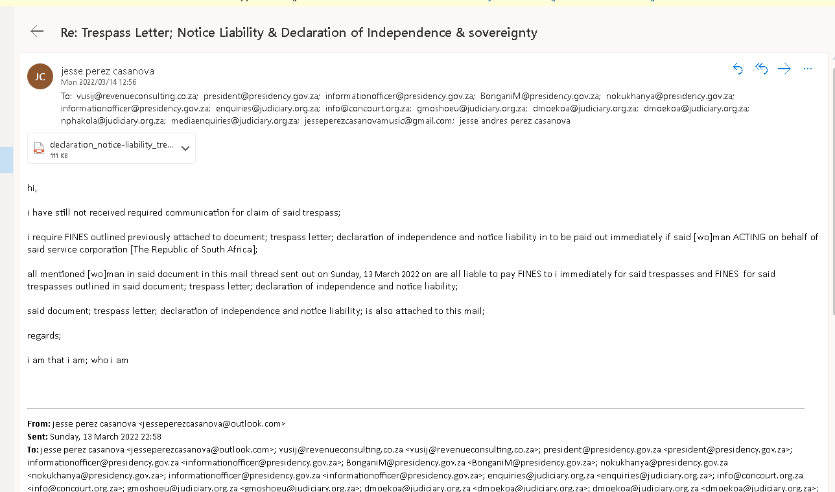
below a screen shot of first given Declaration of independence of i; notice liability; record of wrong doing and trespass letter given on 13th of March 2022 before it was edited updated and given again along with this his trespass letter; record of wrong doing and notice liability is given again on 31st March 2022;

[keep scrolling down]

on the 20th January 2022 at 11:33 AM CAT; the 28th of January 2022 at 10:09 AM CAT and on 28th of January 2022 AT 09:38 AM CAT i received SMS communications from from SABC TV LICENSE to a contact number i use which is +27612708467; these communications expected i am that i am to pay for a TV license for said falsely [fraudulently] created legal person; citizen outlined in declaration of independence of i; notice liability; record of wrong doing and trespass letter first given on 13th March 2022 and given again on 31th March 2022 after being edited and updated;

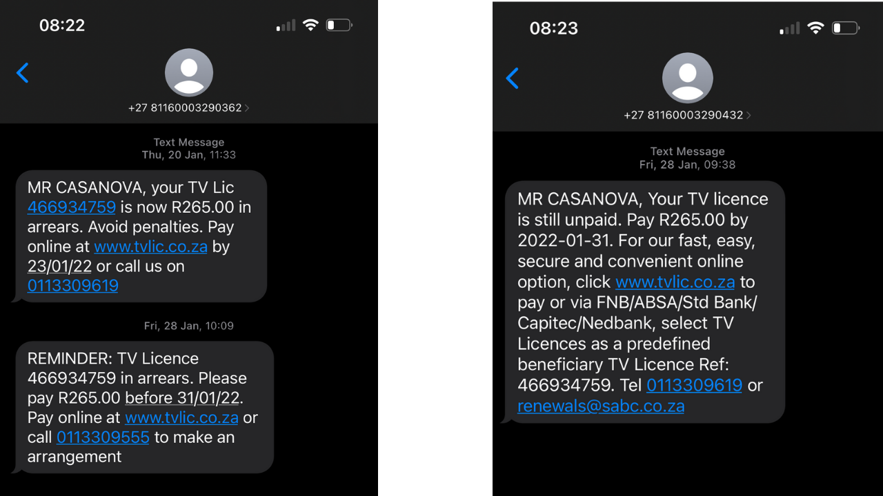

on the 3rd of February 2022 at 11:48 AM CAT and on the 16th of February 2022 09:44 AM CAT i received SMS communications from SABC TV LICENSE to a contact number i use which is +27612708467; these communications continued to falsely [fraudulently]
expect i am that i am to pay for a TV license for said falsely [fraudulently] created legal person; citizen outlined in declaration of independence of i; notice liability; record of wrong doing and trespass letter first given on 13th March 2022 and given again on 31th March 2022 after being edited and updated;
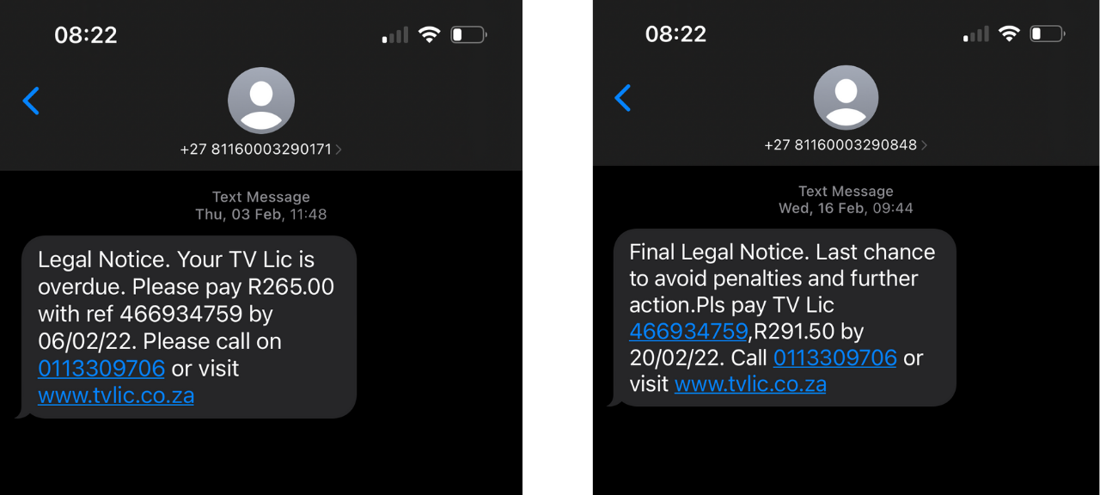
on the 9th of February 2022 at 09:44 AM CAT and on the 23rd of February 2022 at 10:45 AM CAT i received SMS communications to a contact number i use which is +27612708467; these communications continued to falsely [fraudulently] expect i am that i am to pay for a TV license for said falsely [fraudulently] created legal person; citizen outlined in declaration of independence of i; notice liability; record of wrong doing and trespass letter first given on 13th March 2022 and given again on 31th March 2022 after being edited and updated;
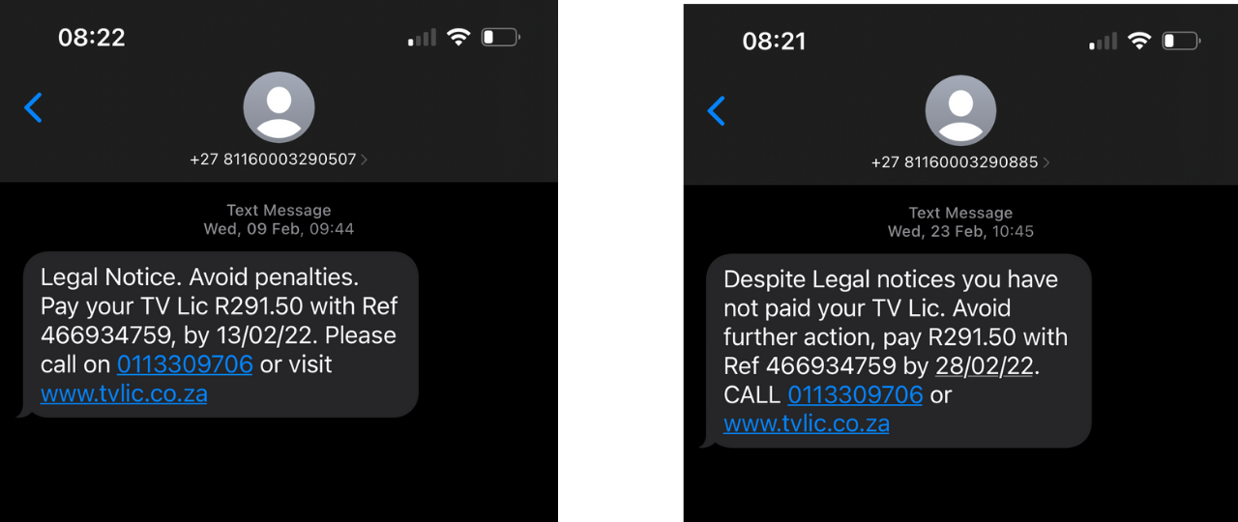

on the 11th of March 2022 at 13:33 PM CAT and on the 18th of March 2022 10:04 AM CAT i received SMS communications from SABC TV LICENSE on the 11th and from REVENUE CONSULTING [REVCO] on the 18th to a contact number i use which is +27612708467; these communications continued to falsely [fraudulently] expect i am that i am to pay for a TV license for said falsely [fraudulently] created legal person; citizen [which i have required to be destroyed] outlined in declaration of independence of i; notice liability; record of wrong doing and trespass letter first given on 13th March 2022 and given again on 31th March 2022 after being edited and updated;
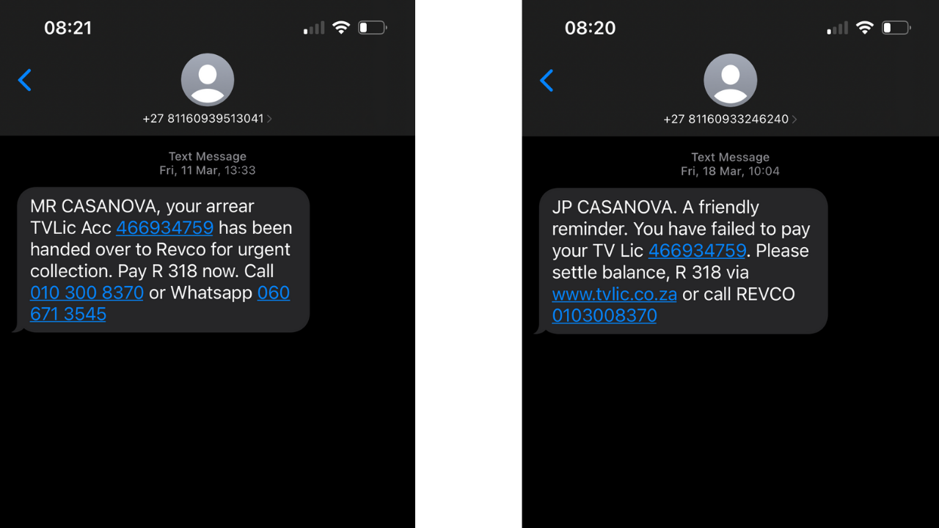

on the 18th of March 2022 at 10:04 AM CAT and on the 25th of March 2022 10:08 AM CAT i received SMS communications from REVENUE CONSULTING [REVCO] to a contact number i use which is +27612708467; these communications continued to falsely [fraudulently] expect i am that i am to pay for a TV license for said falsely [fraudulently] created legal person; citizen [which i have required to be destroyed]
outlined in declaration of independence of i; notice liability; record of wrong doing and trespass letter first given on 13th March 2022 and given again on 31th March 2022 after being edited and updated;
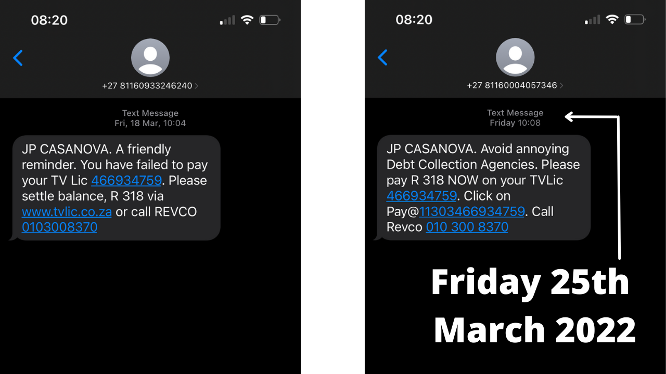
on the 29th of March 2022 at 09:56 AM CAT and on the 30th of January 2022 at 11:40 AM CAT i received SMS communications from REVENUE CONSULTING [REVCO] to a contact number i use which is +27612708467; these communications continued to falsely [fraudulently] expect i am that i am to pay for a TV license for said falsely [fraudulently] created legal person; citizen [which i have required to be destroyed]
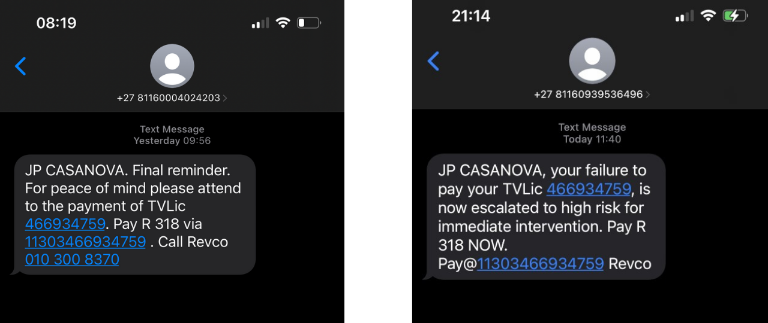
outlined in declaration of independence of i; notice liability; record of wrong doing and trespass letter first given on 13th March 2022 and given again on 31th March 2022 after being edited and updated;

i require a FINE to be paid by [wo]man ACTING as a Director of SABC TV LICENSE SILVIA TLADI;13,000,000.00 south african rand for each time that i received an unlawful [fraudulent] communication from the corporation known as SABC TV LICENSE addressed to said falsely [fraudulently] created legal fiction; person; citizen outlined in said declaration that i required to be destroyed;

i require a FINE from corporation known as SABC TV LICENSE 13,000,000,000.00 south african rand for each time that i received unlawful [fraudulent] communication from the corporation known as SABC TV LICENSE addressed to said falsely [fraudulently] created legal fiction; person; citizen outlined in said declaration that i required to be destroyed;

i require FINE of 13,000,000,000.00 south african rand from service corporation [THE REPUBLIC OF SOUTH AFRICA] for each time that i received unlawful [fraudulent] communication from the corporation known as SABC TV LICENSE addressed to said falsely [fraudulently] created legal fiction; person; citizen outlined in said declaration that i required to be destroyed;

in total i have received seven unlawful communications from corporation known as SABC TV LICENSE falsely [fraudulently] attempting to acquire tacit consent of i; as well as expecting i to unlawfully and falsely [fraudulently] accept liability;

[wo]man ACTING as SILVIA TLADI is required to pay i a total FINE amount of 65,000,000.00 south african rand; this fine is to be paid to i in the here and now; if all of said [wo]man’s property [assets] and revenue are unable to pay the required total FINE then i require that said service corporation pay the remaining balance;

corporation known as SABC TV LICENSE is required to pay i a total of 65,000,000,000.00 south african rand; if all of said corporations property [assets] and revenue are unable to pay the total required FINE then i require that said service corporation pay the remaining balance;

service corporation known as THE REPUBLIC OF SOUTH AFRICA is required to pay i a FINE of 91,000,000,000.00 south african rand; this fine is to be paid to i in the here and now; this FINE is for the seven times that [wo]man ACTING as SILVIA TLADI and the corporation known as SABC TV LICENSE trespassed against i;

i require a FINE to be paid by [wo]man ACTING as Director of Revenue Consulting VUSI JENNINGS 13,000,000.00 south african rand for each time that i received an unlawful [fraudulent] communication from the corporation known as REVCO or REVENUE CONSULTING addressed to said falsely [fraudulently] created legal fiction; person; citizen outlined in said declaration that i required to be destroyed;

i require a FINE from corporation known as REVCO or REVENUE CONSULTING 13,000,000,000.00 south african rand for each time that i received an unlawful [fraudulent] communication from the corporation known as REVCO or REVENUE CONSULTING addressed to said falsely [fraudulently] created legal fiction; person; citizen outlined in said declaration that i required to be destroyed;

i require FINE of 13,000,000,000.00 south african rand to service corporation [THE REPUBLIC OF SOUTH AFRICA] for each time that i received unlawful [fraudulent] communication from the corporation known as REVCO or REVENUE CONSULTING addressed to said falsely [fraudulently] created legal fiction; person; citizen outlined in said declaration that i required to be destroyed;

in total i have received five unlawful communications from REVCO or REVENUE consulting falsely [fraudulently] attempting to acquire tacit consent of i; as well as expecting i to unlawfully and falsely [fraudulently] accept liability;

[wo]man ACTING as VUSI JENNINGS is required to pay i a total FINE amount of 65,000,000.00 south african rand; this fine is to be paid to i in the here and now; if all of said [wo]man’s property [assets] and revenue are unable to pay the total required FINE then i require that said service corporation pay the remaining balance;

corporation known as REVCO or REVENUE CONSULTING is required to pay i a total of 65,000,000,000.00 south african rand; if all of said corporations property [assets] and revenue are unable to pay the total required FINE then i require that said service corporation pay the remaining balance;

service corporation known as THE REPUBLIC OF SOUTH AFRICA is required to pay i a FINE of 65,000,000.00 south african rand; this fine is to be paid to i in the here and now; this FINE is for the five times that [wo]man ACTING as VUSI JENNINGS and the corporation known as REVCO / REVENUE CONSULTING trespassed against i;

The following [wo]man listed below are also all liable for trespass against i;
the [wo]man listed below ACTING as workers [employees] of corporation known as THE CONSTITUTIONAL COURT OF SOUTH AFRICA under the false [fraudulent] control [jurisdiction] of service corporation known as THE REPUBLIC OF SOUTH AFRICA are all responsible for falsely [fraudulently] ACTING as legal persons as well as being responsible for the rules of civil procedure that do not apply to the living i am that i am; listed [wo]man below are liable for continuing to be instrumental in continuation of the constructive trespass [fraud] against i; said trespass regarding falsely [fraudulently] created birth certificates; legal persons and citizen [all information provided in said given declaration]; said [wo]man are also liable for continual attempt to trick [coerce] i and the mankind into falsely [fraudulently] characterizing [representing] i or each of mankind as dead legal fictitious corporations [entities] when i and mankind are not dead but living; said [wo]man are instrumental in falsely [fraudulently] working for a fictional incorporated sovereign nation and legal judicial system that preys on uneducated [wo]man on the law of the land; this same system and service corporation that continually tricks [coerces] mankind into being falsely [fraudulently] characterized as dead corporations; legal person; citizens; drivers; occupants; residents when a contract cannot exist between a corporation and a living [wo]man; as corporations stand on a fictional international maritime admiralty law that is not law but instead deliberately disguised as law under the colour of law; another fictional concept within a fictional service corporation; legal does not apply to a man or a women so all said [wo]man are liable for falsely [fraudulently] ACTING as such key instruments who are responsible for perpetuating coercive modernized slavery in the form of the initial birth certificate fraud used to first trick living [wo]man into being classified as a dead corporation further tricking [coercing] mankind into falsely [fraudulently] standing within fictitious legal jurisdiction; instead of standing on the law of the land which all living [wo]man and life stands on; i pity said [wo]man for being at the helm of a reality powered by such gross trespass [fraud] lies; deception and unwarranted oppression said [wo]man are liable for perpetuating the biggest trespass to ever exist; by continuing to expect i to be a part of this gross constructive trespass [fraud] all said [wo]man are liable for the rampant delusion that affects the lives of i and mankind every single day; said [wo]man have sat at the very same helm responsible tricking [coercing] mankind down a dark path of deception while walking around with the illusion of being free; when it is mankind's lack of knowledge that does not lead mankind to realizing thy right to hold thy natural born rights on the law of the land outside of any maritime corporate legal jurisdiction that could allow mankind to finally be free by refusing to be tricked [coerced] into being considered [represented] as falsely [fraudulently] created fictional legal persons; citizens; drivers; inhabitants; occupants or residents which are not living but instead dead and non existent; the same [wo]man responsible for keeping a fictional legal judicial system alive built on deceit and constructive trespass [fraud]; the reality of unlawful oppression i and mankind live in is thanks to said [wo]man who kept and still keep the greatest lie and constructive trespass away from the knowledge; awareness and minds of mankind; what an awfully gross constructive coercion that makes i sick to my stomach just thinking about it; if only my people knew that they are free; if only they knew that the rules of civil procedure do not apply to any living man or women on the law of the land safely out of the false [fraudulent] control [jurisdiction] of any fictional theoretical legal framework like said service corporation; to think that the [wo]man responsible for working for the constitutional court that is falsely [fraudulently] ocassionally revered as the deliverer of justice; when in fact is not the deliverer of justice but instead a conceptual fictional non existent corporation commandeered by [wo]man hell bent on continually contirbuting the unlawful oppression of i and mankind unlawfully placing i and mankind under duress and fear that leads to falsely [fraudulently] being considered [represented] as a dead corporation lost at sea; living in fear of [wo]man ACTING as uneducated legal enforcement corporations [police services] who are deliberately uneducated in the law of the living on the law of the land; mankind and i forced to live in fear out of corrupt judges that may be paid under oath to distort and lie about the gospel truth when it comes to said constructive trespass [fraud]; unlawful conversions; rights of the living on law of the land and unlawful [fraudulent] overreach by said service corporation and [wo]man working for said service corporation; at the end of the day any [wo]man who falsely [fraudulently] ACTS as a worker [employee] for said service corporations legal judicial system [corporation] are all corrupt and liable for continued constructive trespass [fraud] against i and all mankind;

for the above mentioned trespasses as well as all trespasses communicated in said declaration each [wo]man below is liable for a FINE of 3,000,000,000.00 south african rand required to be paid instantly to i by said [wo]man listed below; if all of said [wo]man’s property [assets] and revenue are unable to pay the total required FINE then i require that said service corporation pay the remaining balance;

[wo]man ACTING as Registrar for KWAZULU-NATAL DIVISION, PIETERMARTIZBURG MS N P FENTE;

[wo]man ACTING as Chief Registrar for LIMPOPO DIVISION, POLOKWANE MS M PHASWANE;

[wo]man ACTING as Registrar for LIMPOPO LOCAL DIVISION, THOHOYANDOU MS J GWANGWA;

[wo]man ACTING as Registrar for NORTHERN CAPE DIVISION, KIMBERLY MR C CONRADIE;

[wo]man ACTING as Chief Registrar for WESTERN CAPE DIVISION,
CAPE TOWN MS ROANNE DAVID;

[wo]man ACTING as Registrar for NORTH WEST DIVISION, MAHIKENG (MMABATHO) MR LM MOKETE
[wo]man ACTING as Acting Chief Registrar for GAUTENG DIVISION, PRETORIA MR S MAPOSSA

[wo]man ACTING as Acting Chief Registrar for GAUTENG DIVISION, PRETORIA MS ROANNE BRAMDAW;
[wo]man ACTING as Registrar of EASTERN CAPE LOCAL DIVISION; MS T MAFALALA

[wo]man ACTING as workers [employees] of the General office of Library of the Constitutional Court; LEGAL NAMES NOT AVAILABLE ON OFFICIAL WEBSITE;
[wo]man ACTING as workers [employees] of the General office of the Constitutional court; LEGAL NAMES NOT AVAILABLE ON OFFICIAL WEBSITE;

[wo]man ACTING as Registrar of the Constitutional Court; LEGAL NAME NOT AVAILABLE ON OFFICIAL WEBSITE;
[wo]man ACTING as JUSTICE JUSTICE RAMMAKA STEVEN MATHOPO; RAMMAKA STEVEN MATHOPO;

[wo]man ACTING as JUSTICE MYBUYISELI MADLANGA; MYBUYISEL RUSSEL MADLANGA;

[wo]man ACTING as JUSTICE STEVEN ARNOLD MAJIEDT; STEVEN ARNOLD MAJIEDT;

[wo]man ACTING as JUSTICE MHLANTLA NONKOSI ZOLISWA; MHLANTLA NONKOSI ZOLISWA;

[wo]man ACTING as JUSTICE THERON, LEONA VALERIE; THERON, LEONA VALERI

[wo]man ACTING as JUSTICE ZUKISA LAURAH LUMKA TSHIQI; ZUKISA LAURAH LUMKA TSHIQI;

[wo]man ACTING as JUSTICE NARANDRA JODY KOLLAPEN; NARANDRA JODY KOLLAPEN;

[wo]man ACTING as Chief Justice RAYMOND ZONDO;
[wo]man who ACTED as Chief Justice MOGOGENG MOGOGENG;

[wo]man ACTING as Director-General PHINDILE BALENI, MS;

Screen shot of communication requirement of FINES given in image below;
this and many other efforts have been put in place by i in order to insure that i continue to have proof of said declaration given on 13th March 2022 to said man [CRYILL RAMAPHOSA] and all [wo]man under control of said service corporation as well as under the control of said man acting as President of said service corporation; as well as all [wo]man who falsely [fraudulently] ACT as legal persons that work for corporations recorded [registered] in said false [fraudulent] service corporation as well as all false corporations that work within said service corporations false [fraudulent] control [jurisdiction]; liability is accepted by both said [wo]man and said service corporation known as THE REPUBLIC OF SOUTH AFRICA;

said man[CYRILL RAMAPHOSA] is required to pay an additional FINE of 13,000,000,000,00 south african rand for each additional trespass made by [wo]man falsely working under control of said man; said service corporation or by corporations recorded [registered] within said service corporations false [fraudulent] control which expects i to falsely [fraudulently] accept liability when i have caused no wrong and harm towards another [wo]man; when no verified claim of trespass showing that i have done wrong and harm to another man or woman exists; where no [wo]man has come fourth to claim i property; when no [wo]man has been proved to be able to administrate property without right;

said [wo]man outlined in the contact information section of said declaration where legal names of [wo]man falsely [fraudulently] ACTING as legal persons and corporations are liable for a FINE of 13,000,000.00 south african rand for each and every time that [wo]man falsely [fraudulently] working under said service corporations control as well as under the control of any [wo]man who work for said service corporation or corporations falsely [fraudulently] recorded [registered] within said service corporation which expects i to falsely [fraudulently] accept liability;

by said [wo]man continuing to unlawfully ACT as the legal names that are falsely [fraudulently] using; the unlawful use of these legal fictions to avoid lawful punishment on the law of the land by attempting to hide behind false [fraudulent] fictional incorporated entities that are falsely presented under the colour of law and not on the law of the land; it is false [fraudulent] for dead corporations which are fictional non living entities that do not stand above the living law of the land to have any control [jurisdiction] over i or mankind;

it is unlawful for i of mankind to ACT as or contract as fictional dead non living corporations such as said corporations; this applies to said [wo]man falsely ACTING as legal persons in said declaration as well as this additional trespass letter & notice liability;

by attempting to falsely [fraudulently] acquire tacit or non tacit consent from i or any of mankind; by expecting i to falsely [fraudulently] represent i as unlawfully created legal fiction; legal person or citizen; further trespasses are occurring against i by all [wo]man who unlawfully work for said service corporation [THE REPUBLIC OF SOUTH AFRICA] as well as for all corporations as well as all [wo]man falsely [fraudulently] recorded [registered] within said service corporations control [jurisdiction];

further trespass letter; record of wrong doing and NOTICE LIABILITY GIVEN;

NOTICE LIABILITY and trespass letter GIVEN to all [wo]man ACTING as workers for said service corporation and all corporations that ACT under said service false [fraudulent] corporations control [jurisdiction];

this includes all [wo]man ACTING as workers [employees] being falsely represented as legal fictions; persons; citizens working for any corporation recorded [registered] as a corporation within said service corporations false [fraudulent; fictitious] corporate legal jurisdiction;

each recorded [registered] corporation recorded [registered] within said service corporation will be FINED 13,000,000,000.00 south african rand for each additional trespass;
each [wo]man falsely ACTING as legal fictions will be FINED 13,000,000.00 south african rand for each additional trespass;

said service corporation will be FINED [THE REPUBLIC OF SOUTH AFRICA] 13,000,000,000.00 south african rand for each additional trespass by ACTORS who falsely work on behalf of said service corporation or corporations recorded [registered] within said service corporation continue to trespass against i;

said man ACTING as president of said service corporation [THE REPUBLIC OF SOUTH AFRICA] will be FINED 13,000,000,000.00 south african rand for each additional trespass by [wo]man working under the false [fraudulent; fictitious] control [jurisdiction] of said man or said service corporation or and recorded corporation within said service corporations false control [jurisdiction] or by any [wo]man who work in said recorded [registered] corporations;

to all said [wo]man outlined in the contact information section of this additional trespass letter and notice liability is also given to; for each said [wo]man outlined in contact information section of said declaration and this said additional notice liability and trespass letter; an additional FINE of 13,000,000.00 south african rand will be required for each trespass against i by any [wo]man or any recorded [registered] corporations under said false [fraudulent] control [jurisdiction] of said service corporation or [wo]man working for any corporation or for said service corporation;

said trespasses are coercive exploitations of i; all said [wo]man are all involved and are all accountable for present and future given FINES;

regards,

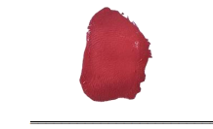
i am that i am; i am who i am;

